PINEMAP Year 2 Interim Report
July 2012
Aim 6

The purpose of the Interim Report is to provide Aim progress updates and get a head start on the process of writing the Year 2 Annual Report (summarizing progress, results, impacts, outcomes, outputs, etc. for the period of January-November 2012).

Please fill in the template as completely as possible and e-mail to Jessica Ireland no later than July 13, 2012.

Outcomes/Impacts

Describe how Aim-level activities, results, findings, techniques, or products contribute to project-level outcomes and impacts.

- Total Number of individuals reached through Aim-6 activities by type of activity: 1892
- Instructor-led training events
  - face-to-face: 1487
  - technology assisted (e.g. webinars): 405
- Self pace events
  - DSS: 160
  - eXtension
  - PDCs
- Committees/Partnerships

- Change in knowledge
  - PINEMAP project awareness
  - Forest/Climate Interactions
  - PINEMAP strategies
  - Climate science

- Adoption of PINEMAP strategies:
- Acres impacted
  - Improved management
  - New planting
- Concomitant results
  - increase in ability to sequester carbon
  - reduction of risk(resiliency)

Outputs

List Products developed/completed January-November 2012 (including published, in press, or in review peer-reviewed publications; other written materials such as white papers, research summaries, fact sheets, or popular press articles; audio or video products; etc.).

Peer-reviewed Publications

Monroe, M.C. and D.C. Adams. 2012. Increasing response rates to Web-based surveys.
Journal of Extension, in press.

Research Summaries

The Six Americas of Climate Change: Perceptions of Southeast Extension Professionals. D.C.
Adams, M.C. Monroe, R. Plate, and D. Wojcik.

Internal Webinar Series-
Aim 6 organized and hosted internal webinars for integration of all PINEMAP members. Webinar presentations were given by Aim 6 members, other PINEMAP members and additional external lecturers.
- Keim, B. (Louisiana State Climatologist) and R. Boyles, Jan. 20, 2012. Basic Climate Change Concepts and Definitions. (21 attendees)
- Domec, J.C. Feb. 3, 2012. The effect of soil texture and nocturnal transpiration on root water uptake and consequences for the future carbon and water budgets of Southern US pine plantations. (25 attendees)
- Zierden, D. (Florida State Climatologist) Feb. 17, 2012. The Drivers of Climate and Climate Variability. (21 attendees)
- Boyles, R. and H.A. Dinon. Mar. 16, 2012. Misconceptions about Global Warming and Climate Change. (17 attendees)
- Konrad, C. (Southeast Regional Climate Center). Apr. 20, 2012. Historical climatology and future projections in the Southeast US. (20 attendees)

Fact Sheets
- Finalized

- In Progress
- To Plant or Not To Plant: New Timber Stand Drought Risk Assessment, Eric Taylor and Matthew Bonham and others
- What can TACCIMO / CACCIMO tell us? Mark Megalos
- Obstacles to Delivering Climate Variability Programming to Traditional Audiences, Mark Megalos (
- Frequently Asked Questions about Climate Projections, Heather Dinon and Ryan Boyles
- Water Cycle in Forested Lands with Emphasis on Silvopasture Systems, Shareika Williams and Gwendolyn Boyd
- Invasive Plants and Your Forest, Christina Temple and Mark Megalos
- Forest Land: Health and Resiliency, Christina Temple and Mark Megalos
- Climate change: Opportunities for Adaptation and Mitigation, Joshua Idassi
- Glossary of Climate Terms, Mark Megalos and Heather Dinon
- Assessing Forest Vulnerability, Mark Megalos and Heather Dinon )
- Southern U.S. Drought, Ryan Boyles and Heather Dinon
- Climate Oscillations: Impacts to Forestry, Heather Dinon and Ryan Boyles
- Introduction to Weather and Climate, Heather Dinon and Ryan Boyles
- What’s Under the Umbrella that is Climate?, Heather Dinon and Ryan Boyles
- Misconceptions about Global Warming and Climate Change, Heather Dinon and Ryan Boyles
- Climate Change and Forestry, Leslie Boby and Heather Dinon
- Interpreting Uncertainty of Climate Model Projections, Heather Dinon and Ryan Boyles
- Herbicide Use Considerations, Eric Taylor
- Minimizing Forest Insect/ Disease Risk: A Practical Landowner Guide, Mark Megalos

Summarize Events/Activities (January 2012-current) as follows:
- Provide a bulleted list of presentations (oral and poster) given at meetings or conferences. The format for citing presentations is as follows:
Presenter(s)/Author(s). Date. Name/title of meeting/conference, location.

January
- Hubbard, W.G., L.A. Boby, R. Sheridan, S. Ashton. Jan. 18-20, 2012. Serving Today’s Agents and the Forestry Community with eTechnology- A Summary of Southern Regional “eXtension” Forestry Activities. University of Georgia, College of Agriculture Extension Winter Conference, Eatonton, GA. (Poster)
- Taylor, E.L. Jan. 21, 2012. Climate Basics and Impact to Forest & Woodlands. Master Naturalist, Gideon Lincecum Chapter. (67 attendees)
- Taylor, E.L. Jan. 21, 2012. Improving Forest and Woodlands Resiliency. Master Naturalist, Gideon Lincecum Chapter. (67 attendees)
- Taylor, E.L. Jan 24, 2012. Health and Vigor in Shade Trees and Woodlands. Harrison County Landowners Meeting. (18 attendees)
- Embrey, M., R. Boyles, P. Knox, S. Schulze, and H.A. Dinon. Jan. 24, 2012. Climate Education Materials With Sector-Focused Context, 21st Symposium on Education as part of the 92nd American Meteorological Society Annual Meeting, New Orleans, LA. (50 attendees)
- Dinon, H.A., L.A. Boby, M.L. Bonham, G. Boyd, R. Boyles, W.G. Hubbard, J. Idassi, T. Martin, M.A. Megalos, M.C. Monroe, and E. Taylor. Jan. 25, 2012. A Regional Approach to Addressing Impacts of Climate Variability and Climate Change on Forest Production in the Southeast U.S., 7th Symposium on Policy and Socio-Economic Research as part of the 92nd American Meteorological Society Annual Meeting, New Orleans, LA. (50 attendees)
- Taylor, E.L. Jan 26. Strategies for Forest Management in Time of Pervasive Change. Marion County Landowner Meeting. (21 attendees)
February
- Megalos, M.A. Feb. 2, 2012 (morning). Variability in Climate: What Should Landowners Do? Robeson County Landowners Association, Lumberton, NC (18 attendees).
- Boby, L.A. and W.G. Hubbard. February 7, 2012. PINEMAP Overview. Webinar meeting with state extension foresters. Web-based Seminar. (14 attendees)
- Taylor, E.L. Feb. 8, 2012. Strategies for Forest Management in Times of Pervasive Change. Forest Drought Symposium, Dibol, TX. (200 attendees)
- Taylor, E.L. Feb. 10, 2012. Forest Pest Application Safety. Forest Pest Seminar, Lufkin, TX. (73 attendees)
- Megalos, M.A. Feb. 12, 2012 (afternoon). Variability in Climate: What Should Landowners Do? Cumberland County Landowners Association, Fayetteville, NC (26 attendees)
- Nielsen-Gammon, J. (Texas State Climatologist). Feb. 10, 2012. Weather Trends and Long Term Forecast. Forest Pest Seminar, Lufkin, TX. (73 attendees)
- Taylor, E.L. Feb. 17, 2012. Stand Establishment Strategies in Light of an Uncertain Future. Harrison County Landowner Meeting, Marshall, TX. (23 attendees)
- Boby, L.A. and W.G. Hubbard. Feb. 19-21, 2012. A Regional Approach to Climate Variability Extension Delivery. Southeastern Society of American Foresters. Jekyll Island, GA. (Poster)
- Boby, L. A. and W.G. Hubbard. Feb. 23-24, 2012. PINEMAP overview. Southern Regional Extension Forestry’s Annual Unit Leaders Meeting. Athens, GA. (25 attendees)
- Taylor, E.L. Feb. 25, 2012. Improving Forest and Woodlands Resiliency. Central Texas Forest, Woodland and Drought Meeting. Cat Springs, TX. (160 attendees)
- Monroe, M.M., D.C. Adams, and D. Wocjik, Southeast Extension Faculty Perceptions of Climate Change. Forestry PINEMAP Webinar, February 7, 2012. (9 attendees)

March
- Taylor, E.L. Mar. 8, 2012. Strategies for Improving Forest Management in Time of Pervasive Change. Smith County Farm and Ranch Meeting, Tyler, TX. (18 attendees)
- Megalos, M.A. Mar. 27. 2012. Introduction to Climate Vulnerability. PINEMAP Online Graduate Class presentation (28 attendees)
- Vuola, A.J. Mar. 30, 2012. North Carolina Cooperative Extension Perceptions and the Six Americas of Climate Change. Master's Thesis Presentation to faculty and staff. NC State University, Raleigh, NC. (20 attendees)

April
- Megalos, M.A. Apr. 10, 2012. Weather and climate variability: What should foresters do? Southern Pines, NC Sandhills Society of American Foresters and Forestry Club. (36 attendees)
- Dinon, H.A., L.A. Boby, M.L. Bonham, G. Boyd, R. Boyles, W.G. Hubbard, J. Idassi, T. Martin, M.A. Megalos, M.C. Monroe, and E. Taylor. April 11, 2012. PINEMAP: Progress and future plans (poster), Southeast Climate Consortium 2012 Spring Program Review, Auburn, AL.
- Megalos, M.A. and H.A. Dinon. Apr. 17, 2012. How Do We Manage Risks Related to Extreme Weather? Harnett County Forestry Association. Lillington, NC (18 attendees)
- Dinon, H.A. and M.A. Megalos. April 17, 2012. Introduction to Weather and Climate in North Carolina, Landowner meeting in Harnett County, NC. (18 attendees)
- Nielsen-Gammon, J. (Texas State Climatologist). April 18, 2012. Texas Drought; 2012 and Beyond. Texas Society of American Foresters Annual Meeting, Huntsville, TX. (80 attendees)
- Boyles, R. and H.A. Dinon. Apr. 25, 2012. Misconceptions about Global Warming and Climate Change, Southern Region Extension Forestry Webinar. (210 attendees)
- Taylor, E.L. Apr. 26, 2012. Timber Management Strategies. 1890’s Small Scale Producer Conference. Texarkana, TX. (8 attendees)
- Hubbard, W.G., Update on PINEMAP Activities. April 10th, 2012. Association of Southern Regional Extension Directors (ASRED), Nashville, TN. (20 attendees)
- Adams, D.C., M.C. Monroe, D. Wocjik, and R. Plate, Extension Perceptions of Climate Change. Livestock and Poultry Climate Change Adaption and Mitigation Workshop, Southeast Climate Consortium Meeting, Auburn, AL, April 9, 2012.

May
- Megalos, M.A. May 3, 2012. Forest Climate Variability: What Should Landowners Do? North Carolina Chapter of Association of Consulting Foresters, Holly Springs, NC (50 attendees)

PINEMAP Annual Meeting, May 15-16, 2012, Atlanta, GA
- Boby, L.A. and W.G. Hubbard. May 15-16, 2012. PINEMAP: Extension Delivery. PINEMAP Annual Meeting/Atlanta, GA [Poster].
- Boyles, R. and H.A. Dinon. May 15-16, 2012. PINEMAP Decision Support System (DSS), PINEMAP Annual Meeting, Atlanta, GA. (80 attendees)
- Boyles, R. and H.A. Dinon. May 15-16, 2012. PINEMAP Decision Support System (DSS) Group Activity, PINEMAP Annual Meeting, Atlanta, GA. (80 attendees)
- Krantz, S., M C. Monroe, and W-L Bartels. Climate change perceptions of Florida forest landowners. PINEMAP Annual Conference, May 15-16, Atlanta, GA. [Poster].
- Monroe, M. C., D. C. Adams, R. Plate, and D. J. Wojcik. 2012. The Six Americas of Climate Change: Perceptions of Southeast Extension Professionals. PINEMAP Annual Conference, May 15-16, Atlanta, GA. [Poster].
- Vuola, A.J. and M.A. Megalos. May 15-16, 2012. Climate Variability Programming Limitations among north Carolina Cooperative Extension Professionals & North Carolina Cooperative extension Perceptions and the Six Americas of Climate Change. PINEMAP Annual Meeting. Atlanta, GA [Poster]
ANREP Meeting, May 20-23, 2012
- Boby, L.A. and Hubbard, W.G. PINEMAP: Extension Delivery. ANREP Biannual Conference, May 20-23, 2012, Hendersonville, NC. [Poster]
- Krantz, S., M C. Monroe, and W-L Bartels. Climate change perceptions of Florida forest landowners. Association of Natural Resource Extension Professionals (ANREP) Biannual Conference, May 20-23, 2012, Hendersonville, NC. [Poster].
- Monroe, M. C., D. C. Adams, R. Plate, and D. J. Wojcik. 2012. Perceptions of climate change among southern Extension professionals: Survey results and a comparison to “Six Americas.” ANREP Biannual Conference, May 20-23, 2012, Hendersonville, NC. [Concurrent session]. (40 attendees)
- Bardon, R., E.L. Taylor, W. Hubbard, M. Bonham. May 20-23. 2012. Where are we going with Technology Assisted Extension Programming: A Roundtable to Discuss the Future. [Poster]
- Taylor, E.L. M. Bonham, Y. Li. May 20-23, 2012. A Framework for the Economic Valuation of Forest Ecosystem Cultural Services in Texas. [Poster]
- Jennings, L.J., E. Taylor, V. Simone-Brown, H. Dinon, R. Boyles, E.A. Treasure, S.G. McNulty, M. Bonham, C. Liggett, M. Megalos, L.A. Boby, W.G. Hubbard, J.A. Moore Myers, R.L. Herring, D. Merriweather, P. Arndt, M. Monroe and G. Boyd. It’s Getting Hot Out Here: An Interactive Workshop Focused on Communicating Climate Change For Natural Resource Professionals. ANREP Biannual Conference, May 20-23, 2012, Hendersonville, NC. [Concurrent session/Workshop]. (50 attendees)
Workshop Narrative
In this workshop, participants explored the daunting and divisive task of teaching about climate change, as well as the natural resource impacts of climate variability and tools that can be used to address its effects. As extension professionals, it is crucial that we incorporate the best science-based knowledge and understanding about all factors that impact natural resource management into our educational programs. Our goals for this workshop were comprehensive and included: understanding taboos and barriers that make climate change conversation difficult; a primer on climate, climate variability and climate change as it relates to natural resource management; and finally, management tools that will help natural resource managers deal with climate change effects.
- Taylor, E., W.G. Hubbard, M. Megalos, H.A. Dinon, L.A. Boby and others. CSI: Climate Science Initiative, ANREP. ANREP Biannual Conference, May 20-23, 2012, Hendersonville, NC. [Concurrent session/Workshop]. (24 attendees)
Workshop Narrative
In this workshop, ANREP conference attendees with an interest and projects in climate change education and effects met to discuss efforts based on educating extension agents and through them, the general public on the importance of climate science, climate change information and strategies they (and we) can use to educate the public.
- Boyles, R. May 22-23, 2012. Misconceptions about Global Warming and Climate Change. Texas Annual Coop Meeting (WGFTIP) [online webinar]. (40 attendees)

June
- Boby, L.A. and Hubbard, W.G. PINEMAP Overview. Southern Group of State Foresters Meeting, June 13-15, 2012, Louisville, KY. (17 attendees)
- Monroe, M. C., D. C. Adams, R. Plate, and D. Wojcik. The Six Americas of Climate Change: Perceptions of Southeast Extension Professionals. Florida Extension Administration Meeting, June 14, 2012, Gainesville FL. [invited presentation]. (15 attendees)
- Monroe, M. C., D. C. Adams, R. Plate, and D. Wojcik. The Six Americas of Climate Change: Perceptions of Southeast Extension Professionals. Florida Extension Administration Meeting, June 14, 2012, Gainesville FL. [invited presentation]. (12 attendees)
Workshop Narrative:
We organized and implemented a forest landowner meeting in Tallahassee with county agent Stan Rosenthal, inviting 325 landowners in the five county regions currently on the Forest Stewardship mailing list. Fifteen landowners, 2 agents, 4 specialists, 2 staff, and 3 students attended. The Florida State Climatologist, Dr. David Zierden, oriented the group to climate change and seasonal variation due to El Niño and La Niña and responded to questions. After a short break, three SFRC professors provided short presentations connecting their work to climate changes and the panel responded to questions. Dr. Tim Martin (forest disturbance), Dr. Jason Smith (forest health), and Dr. Patrick Minogue (forest management) helped landowners think about management options that increase forest resilience given expected fluctuations in precipitation and temperature and impacts such as wildfire and insect pests. A pre/post survey helped measure participants’ opinions and interest in adopting management changes.
- Vuola, A.J. Jun. 6, 2012. North Carolina Cooperative Extension Perceptions and the Six Americas of Climate Change. Presentation to Atlantis Program faculty and students (United States/Europe graduate Exchange Program. NC State University, Raleigh, NC (30 participants)

- Provide a short narrative describing experiments or surveys conducted and/or analyzed.

In 2011-2012, M.C. Monroe and D.C. Adams conducted a study of extension professionals in the southeast, to assess their perceptions of climate change and global warming as ‘Six Americas’. The survey included 2,418 responses from extension professionals in eight southern states. Results are being analyzed.

Milestones and Work Plan Progress

All year 2 milestones and work plan tasks have been listed below. Provide a short narrative describing progress on each; if work on milestone or task has not yet begun, leave blank.

Milestones

Implement and strengthen forestry Extension/climatologist partnership.
Aim 6 has identified three strategies within this milestone and progress has occurred on many aspects.
- Local training: State climatologists have been approached singly and as a group, to become members of the PINEMAP delivery teams to help plan and execute local workshops and distance education training programs. Additionally, Aim 6 members have established individual relationships with their respective state climatologists and engaged with them on workshops as well as to review materials.
- Climate expertise to support research: Aim 6 members have surveyed many climatologists to learn more about their backgrounds and specialties and to use them as resources for PINEMAP research and products.
- Integrating climate and forestry research with extension expertise: AIM 6 members (including climatologists) are developing the Decision Support System (DSS) to utilize climate and forestry data, including PINEMAP research for dissemination. This DSS will utilize climate and forestry research and use an extension approach to reach stakeholders and design a user-friendly interface.
Three climatologists from the PINEMAP region attended the Association of Natural Resource Extension Professionals (ANREP) conference in Hendersonville, NC during May 2012. The climatologists also were able to attend the post-conference ANREP Climate Science Initiative meeting. There has been active collaboration on several workshops, presentations, and/or webinars in Texas between John Nielsen-Gammon, Eric Taylor, and Matt Bonham as well as in North Carolina between Mark Megalos, Ryan Boyles, and Heather Dinon. In addition, Georgia partnerships have been initiated between Pam Knox, David Stooksbury, Leslie Boby, and Bill Hubbard as well as Florida partnerships between David Zierden and Martha Monroe. Several climatologists have partnered with us to give presentations as part of the PINEMAP internal webinar series.
Audience/Needs Assessments
These are critical for better understanding stakeholders themselves as well as determining their needs and thus, the direction of PINEMAP extension programs and products.
- Extension staff: During year 1, Aim 6 staff conducted an audience assessment survey of all extension staff throughout 8 states in the southeastern U.S. This survey was designed to access attitudes, beliefs, practices and interest in global warming and climate change programs and programming. Results of that survey, as well as summaries were written up in 2011’s annual report. Results have been presented at >>>> many conferences.

- Forestry Professional: Aim 6 members have recently completed a survey for professional foresters (includes consulting foresters, extension foresters and others). This survey will be conducted in the next few months and we will utilize a large database of forester contacts to reach as many people as possible. This needs assessment will examine forester and natural resource professionals needs for continuing education programs on increasing forest productivity (particularly pine plantation productivity) and resilience to extreme weather, climate variability and climate change. Specifically, participants will be questioned on their personal experiences and understanding of current and future effects of climate change on forestry management. We will also question attitudes and knowledge about climate change, climate variability, etc., with a focus towards developing the best approach for meeting perceived and actual needs. We will also query professionals on climate resiliency and forest “weather-proofing” areas they are interested in learning more about.

- The AIM 6 team has also completed and deployed the Texas FRESH (Forest Resources, Ecosystem Services and Health) Survey, both in hard copy and web versions. The intent of the survey is to get a better feel for the benefits that Texans associate with forests, and eventually use this data to support incentive programs to improve the management of Texas forests and woodlands. Data will be collected and analyzed in the second half of 2012. Analyzed data from this survey will also be used to direct and support PINEMAP education programs.

Extension Programs Evaluated
It is important to develop evaluation instruments that will be use across the region to provide consistency with questions asked, etc.
- Retrospective Post – Family Forest Landowners: This retrospective-post evaluation allows the host to select/modify the types of question asked depending upon the topics of the training event. However, still maintain rigidity and consistency across the region. The form is scan tron to ease analyses.
- Retrospective Post – Natural Resource Manager: currently under development but will be retrospective-post, scan tron form with the ability to select questions from a pool of allowable questions designed to measure the impact of PINEMAP outreach programs.
- Follow-Up Surveys – Family Forest Landowners: under development.
- Follow-Up Surveys – Natural Resource Manager: under development

Extension Programs Delivered
We have ongoing extension programs as listed in the events/activities section. We are also planning four regional workshops on forest resiliency, which will incorporate PINEMAP information and will be supportive of PINEMAP goals. We will include feedback from completed audience assessments and evaluations as we continue to develop these workshops and more extension programs.

State extension & climatologist teams organized.
A conference call with the state extension team was held in February 2012. Initial conference calls with climatologists across the region were held in December 2011. Another round of joint calls between the two groups is being planned for August 2012.

Decision Support System
Ryan Boyles and Heather Dinon have developed a subcommittee composed of at least one PINEMAP member from each Aim to provide guidance for the Decision Support System (DSS). This subcommittee has provided a list of existing tools and inputs/outputs from each aim for the DSS. A presentation and group activity at the annual meeting identified different ideas for the design of the DSS. Some of these ideas are shown in the figures below. Meetings with the DSS subcommittee will continue on a bi-monthly basis. .
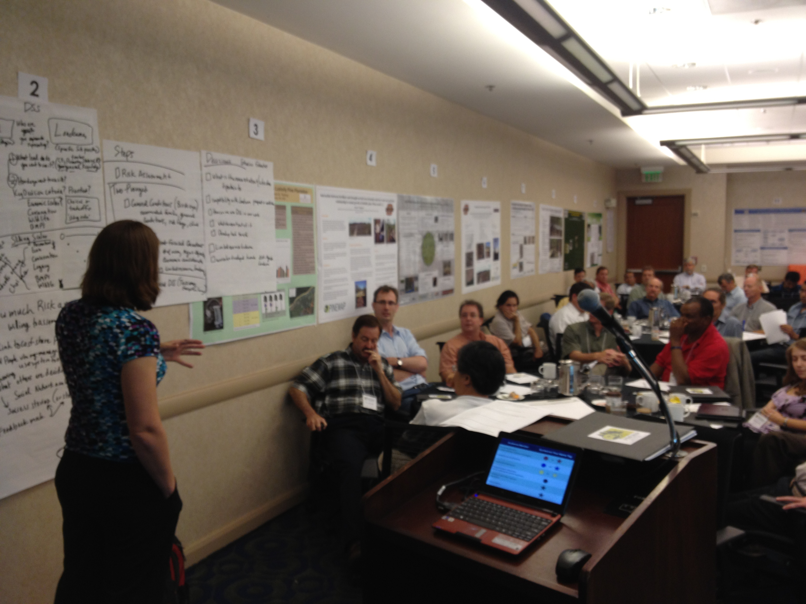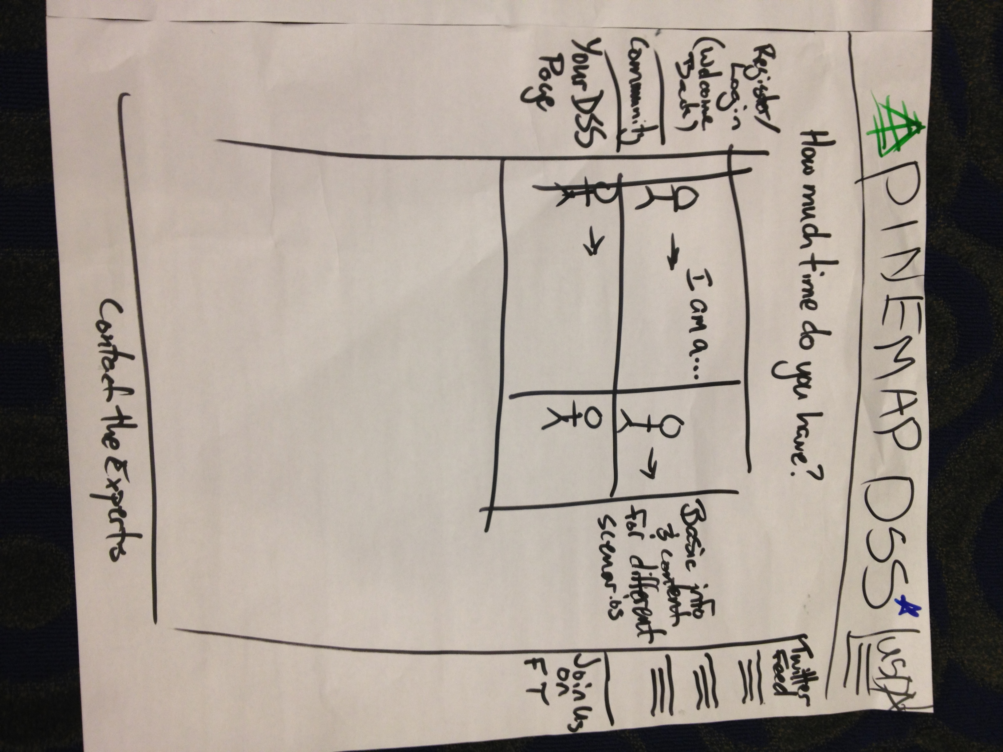
PINEMAP members working together during DSS activity. DSS design for a family forest landowner.

Work Plan Tasks

Audience assessment—develop several “baseline” survey instruments that establish the existing knowledge levels, needs, beliefs, interests, attitudes, learning preferences, etc. regarding climate variability and forest interactions for various groups.
The audience assessment has been developed and will be implemented in the latter half of 2012. Additionally, we have assembled a large database of forestry professionals across the southeastern United States for distributing the survey.

Strengthen relationships with education, research, and stakeholders: State/regional advisory planning meetings.
Aim 6 members will continue outreach activities including attending Forestry Cooperative Meetings, and other forestry related workshops and conferences. We will continue to coordinate the PINEMAP internal webinar series and will have each Aim group take turns presenting monthly, as well as including presentations on new developments and other research topics. Aim 6 members have joined other Aim’s listservs and will attend their in-person and virtual meetings as much as possible.

Creation of regional advisory panels.
Invitations to a webinar based meeting about PINEMAP’s regional advisory panel were sent to more than 20 state level extension foresters and 1890’s University’s extension foresters in the early part of this year. About 10 foresters attended this initial meeting and expressed interest in evaluating PINEMAP extension products and plans.

External outputs (fact sheets, web-based climate education modules, complete analysis and submit articles on SE Extension perceptions of climate change, eXtension, etc.).
Numerous factsheets are currently in draft form with expected publication in the second half of this year. Factsheet review guidelines have been established and will be used to vet all PINEMAP publications. Additionally, official formats and templates for PINEMAP factsheets have been selected. All publications will be submitted to the Climate, Forest and Woodlands Community of Practice on eXtension. Web-based climate education materials are being adapted for forestry, with a goal of creating a ‘certificate’ program through another agency (such as Society of American Foresters) in Climate Smart Forest Management. The theme has been built and topics are being reviewed for relevance to our stakeholders. Contextual examples are being developed for the topics that are most important to our target audience(s). Some of these materials will be implemented into eXtension.

Administrative activities
We will continue with PINEMAP reports, monthly web conferencing meetings and biannual in-person meetings. We will assist in the maintenance of the project website, provide content for PINEMAP Facebook page and attend monthly executive committee meetings. Our continuing goal is to strengthen relationships with other Aim groups.

Annual Report Sidebars

We will highlight interesting results, stories, or successes for each Aim in sidebars in the annual report. Please identify at least two items from your Aim that will become sidebars for the annual report. Each sidebar should be illustrated with a figure, table, or photograph that will draw attention. In addition, provide a paragraph of text summarizing the experiment, project, or result.
Ideas for Sidebars:
- DSS creation with Heather and Ryan (perhaps a picture from the meeting).
- Engaging State Climatologists- finding the link between their mission and ours
- Add pictures from ANREP workshop
- Mention new Facebook page

Broad Impacts & External Collaborations

Provide a short narrative describing broad impacts (i.e., far-reaching and possibly unanticipated outcomes resulting from Aim work, including contacts/collaborations with entities outside of PINEMAP).

The work of Aim 6 in extension necessitates cultivating contacts and collaborations with outside entities in order to be successful. To this end, some of our outreach efforts are targeted towards state level forestry extension personnel who can link us with stakeholders (i.e. forest landowners, industrial forestry members, county level extension agents). Aim 6 is already using the traditional forestry extension networks to reach our stakeholders, but beyond this, we have developed new contacts and collaborations through working with state climatologists and interacting with ANREP members, as well as potential regional advisory board members.

Aim 6 members are partnering with other forestry extension professionals to implement, “Natural Resources Resource Opportunities For Landowners,” a web-based 5 class series which will focus on the basics of natural resources and private land and serve as an introductory course to ‘Master Tree Farmers,’ a more intensive course on forestry techniques for the private landowner. Through these courses, PINEMAP members will have access to private landowners and a further ways to engage

A partnership has been initiated with Nicole Wulff, Changing Roles Training Coordinator with US Forest Service Southern Research Station. Heather Dinon has reviewed a fact sheet on the basics of climate change and Leslie Boby reviewed two climate change and forestry exercises and factsheets for Nicole's group. Aim 6 members also recently collaborated with US Forest Service’s “Template for Assessing Climate Change Impacts and Management Options” (TACCIMO) Project Staff on a workshop at the ANREP meeting and have shared ideas for further exchange of ideas as our project develops.
Presentations and discussions by Martha Monroe, of the results of the Six America’s survey with SE Extension Professionals has generated interest among state leadership in Florida and Pennsylvania to carefully consider how to organize in-service training and deliver programs on climate change, and is being used in the Association of Natural Resource Professionals (ANREP)’s Climate Science Initiative.
Training

Please list undergraduate and graduate students, postdocs, and technical personnel trained under this project and include a description of their research focus and/or role in the project.

A list is provided from the Year 1 Annual Report; please update as necessary to cover the time period January-November 2012.

- Leslie Boby, Extension Associate, Southern Regional Extension Forestry. Leslie is assisting with formation of regional Extension teams and a PINEMAP Extension Advisory Board; participating in and presenting at research cooperative meetings; and facilitating internal and external PINEMAP research dissemination. Planned work includes developing and evaluating written and web-based (i.e., eXtension, webinars, etc.) educational materials and disseminating resources and materials to forestry stakeholders.
- Rachel Burnett, Graduate Research Assistant, North Carolina State University. Rachel is assisting with reviewing factsheets and other PINEMAP-related publications.
- Matthew Bonham, Extension Assistant, Texas AgriLife Extension. Matt is assisting with formation of state Extension teams; implementing, coordinating, and hosting the PINEMAP internal webinar series; initiating the Texas Forest/Woodland Advisory Panel; contributing to regional fact sheets and extension modules in the areas of forest management and climate interactions; reviewing current eXtension materials to identify knowledge gaps; and creating several feedback instruments to gauge the effectiveness of outreach activities and identify areas for improvement.
- Hilary Cole, Graduate Research Assistant, North Carolina State University. Hilary is serving as a copy editor for factsheets and other PINEMAP-related publications. She is also providing guidance with contextual examples for the climate education materials in collaboration with the State Climate Office of NC.
- Heather Dinon, Applied Climatologist, State Climate Office of North Carolina. Heather is facilitating interaction between PINEMAP team members and state climatologists across the region through activities such as presentations in the internal webinar series and research cooperative meetings and weather/climate conferences. Other involvement includes development of the DSS, creation of fact sheets, and guidance on the best climate datasets for PINEMAP.
- Anslei Foster, Graduate student, North Carolina A&T University. Anslei is working on factsheets and publications for PINEMAP.
- Shelby Krantz, Undergraduate IFAS Research Intern, University of Florida. Shelby conducted focus groups, helped design the forest landowner Extension workshop, developed a pre/post survey and analyzed data to better understand perceptions on climate, willingness to change management strategies, and opportunities to make a meaningful difference.
- Charlie O’Connell, Undergraduate Research Assistant, North Carolina State University/State Climate Office of NC. Charlie is reviewing the climate education materials for forestry as well as developing a tool for forestry professionals across the southern US which displays historical temperature, precipitation, and drought indices.
- Richard Plate, Postdoctoral Associate, University of Florida. Dr. Plate is assisting with data analysis for the Extension climate perceptions survey.
- Christina Temple, M.S. candidate, North Carolina State University. Christina is developing two fact sheets on adaptation related to forest pests and invasive species. Drafts are done and being edited by Hilary Cole.
- Aaron Vuola, M.S. candidate, North Carolina State University. Aaron successfully defended his thesis on 3/30, graduated in May 2012 and is in the process of drafting two publications over the summer from his thesis work. Hilary Cole may assist on the editing of these publications, one of which has been accepted as a poster for an upcoming conference in MA this fall.
- Tiffany Williams, Research Assistant, Southern Regional Extension Forestry. Tiffany is developing a comprehensive list of climate education materials across the southern US.
- Deborah Wojcik, Postdoctoral Associate, University of Florida. Dr. Wojcik is assisting with survey development and data analysis for the Extension climate perceptions survey. Dr. Wojcik helped develop the Six Americas survey for SE Extension Professionals and is writing one article.

Collaborations and “integrated” knowledge developed

Provide a short narrative describing new ideas, research questions, or insights that have arisen through work and discussions with colleagues, stakeholders, and others. In addition, explain the extent to which you intend to incorporate this into PINEMAP milestones and/or your Aim work plan.
Aim 6 is an extension group and we are not generating direct primary research equivalent to Aims 1-4, however, our work on the DSS requires ideas, research and insights from all other aims in order to create the best system. Martha Monroe’s work with the “Six Americas” survey has yielded useful insights for those of us working with extension professionals in the Southeast. This information is also important for Aims 1-4 to understand, as it impacts how we deliver information and what information people are most concerned about. Our Professional Foresters Survey should also yield some interesting insights that may be especially important for Aim 4.

Needs from/linkages to other Aim groups

Provide a bulleted list outlining research results, data, products, or assistance that your Aim group needs from another Aim group.
- Research results and guidance is needed from Aims 1 to 4 for the DSS development. Aim 5 will also be contributing to the DSS and several other Aim 6 activities, such as workshops and survey work.

- Provide a bulleted list outlining research results, data, or products that your Aim group has compiled that have value or relevance to another Aim group (and note which Aim group).

- Provided guidance to Asko Noormets (Aims 1 and 2) on which historical datasets were most useful for his PINEMAP research.
- Heather Dinon and Ryan Boyles served as coordinators for two Elluminate webinars for the PINEMAP distance education graduate course on: 1) “Climate model projections in the southern US” with guest lecture by Dr. Katharine Hayhoe, and 2) “PINEMAP Decision Support System”.
- Bill Hubbard and Mark Megalos coordinated Assignment 2 as part of the PINEMAP graduate course. Several Powerpoints were prepared and the webinars are archived. Also, Leslie Boby, Matt Bonham, and Heather Dinon were reviewers for Assignment 2.
- Heather Dinon, Charlie O’Connell, and Megan Hall are reviewing material for Project Learning Tree activities as related to climate and forests.
- Providing feedback to Aims 1-4 on stakeholder needs and how this may influence research choices.

- List any additional potential linkages to other Aim groups.
Aim 6 members will continue to cultivate relationships with other Aim groups to stay current on the newest developments in research and the potential for extension products developed from that research. It is critical for Aim 6 members to be knowledgeable about other Aims’ research in order to successfully build the DSS.

Leveraged funding/additional resources

Describe how PINEMAP funds were leveraged as well as any additional resources obtained. Please list amounts and sources.
- Martha Monroe, Anonymous donation to cover food for focus groups, travel to extension offices ($1500)
- ANREP student scholarship, for Shelby Krantz ($1000)
- UF IFAS Student Research Internship for Shelby Krantz ($3360)
- Megan Hall, a graduate research assistant at the State Climate Office of NC, is coordinating the effort to adapt the climate education materials to other sectors, including forestry, in collaboration with our PINEMAP team. She is also reviewing materials for PLT in collaboration with Aim 5.
- Graduate students Hilary Cole and Rachel Burnett have funding from other sources as well.

Work planned/progress expected

Briefly describe a forecast of Aim work planned and progress expected for June-December 2012. If there are any major changes to the Aim year 2 work plan, please also explain here.

In the second half of this year, Aim 6 will continue to make progress on work begun over the past 18 months. It is expected that nearly all of the publications in draft form will be published within the next six months. Workshops on forest resiliency (including PINEMAP message) will be conducted in the fall and through the spring of next year. Additionally, we will use any opportunity to reach stakeholders with the PINEMAP message. In general, we will continue to follow the Aim 6 year 2 work plan.

PINEMAP Newsletter

The purpose of the PINEMAP newsletter is to highlight and summarize PINEMAP project updates, research results and experiments, outputs such as products/events/activities, etc. The target audience includes the general public, internal PINEMAP collaborators, stakeholders, NIFA, and external partners. The anticipated publication date for the first newsletter is sometime in August or September 2012.

Please identify a topic for a brief (300-500 word) article for the first issue of the PINEMAP newsletter. Outline a preliminary article title, provide a brief (3-5 sentence) summary, and list authors.

- Educating Non-industrial private landowners through a popular landowner education series. Leslie Boby and Bill Hubbard
  - Aim 6 members are working in conjunction with other state level forestry extension to revive the popular Master Tree Farmer and Master Wildlifer landowner education series. This educational course will address a wide variety of natural resource issues and introduce concepts to motivate landowners to use better techniques for managing their forested lands (for production and other uses).
- The Six Americas of Southeast Extension Professionals’ Climate Change Perceptions
Martha C. Monroe, Damian C. Adams, Richard Plate, and Deborah J. Wojcik
An essential part of the PINEMAP project is effective communication with extension agents about climate change, adaptive strategies using planted pine forests, and impacts on forest landowners. We know that climate change generates reactions from deep concern to disbelief. Regional outreach programs that develop materials for extension agents must understand two audiences–the extension agent and the ultimate receiver to be effective. Previous research suggests that Americans fall into six categories, or “Six Americas,” with their perspectives on climate change (alarmed to dismissive). Our 2011-2012 study used a 56-item web-based survey to collect data from extension professionals (n=2,758) in eight southeastern states and classify them according to the Six Americas spectrum. Respondents mirror the national pattern with a skew toward the dismissive. Several factors are strongly associated with climate change perceptions, such as location (e.g., those from coastal counties are more likely to be alarmed and concerned), political leaning (e.g., conservatives are more likely to be doubtful and dismissive), major program area (e.g., agriculture agents are more doubtful and dismissive), and position in extension (e.g., agents are least concerned). Our findings have implications for program development, long term education strategies, and messaging.

