Purpose of Tier2 (intensive) sites: provide a context for characterizing the representativeness of Tier3 sites in the Tier1 network
Requirements for Tier2 intensive sites: represent the extent and sources of variability in productivity, C stocks (esp. soil), SR and WUE
Presumed main sources of variability for productivity, C stocks, SR and WUE:
- Age
- Physiographic region / soils
- Latitude / climate
- …
Instrumentation is available for only 6 sites. Thus, only 2 factors can be covered in a factorial design (prioritization of factors may vary by sub-region). Alternatively, a uniform spatial coverage may be attempted (at the risk of incomplete coverage of key driving factors; furthermore, Tier2 sites are not uniformly distributed).
Selection matrix: Age (# of levels: 2-3) × Physiographic Region (1-2) × Climate (1-2) = 6
2A × 2PR × 2C = 8
3A × 2PR = 6
Notes about northern subregion:
- The selection outlined on following pages is currently set up as a paired study of physiographic regions across age. This brings with it a few problems:
  - No true replication is possible
  - Latitude is confounding with age. Moving younger sites southward might help ameliorate this effect.
  - Medium age group is too old – need to target 10-12 year old (instead 13-20)
Questions to Aim1 group:
- Which criteria to use? Should they be uniform across PINEMAP range?
- What thresholds to use for different criteria?
Wen Lin’s notes
- General information
  - 31 sites
  - Age range: 3-28
  - Two physiographic regions: piedmont and coastal plain
  - All tier II sites in northern sub-region
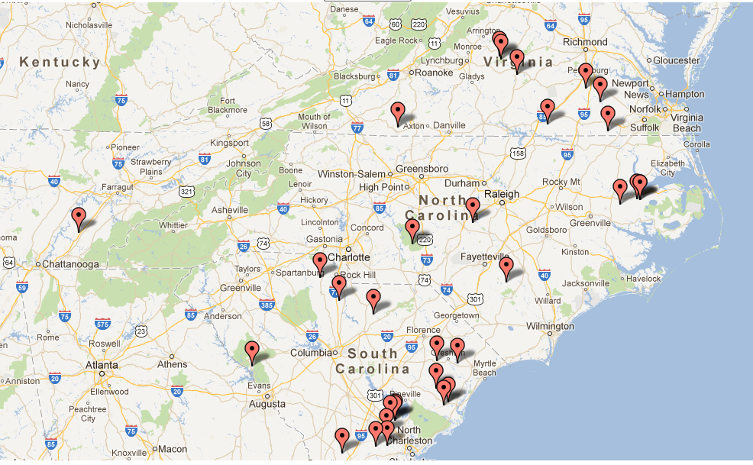

- Age
  - Distribution (not include culled sites)
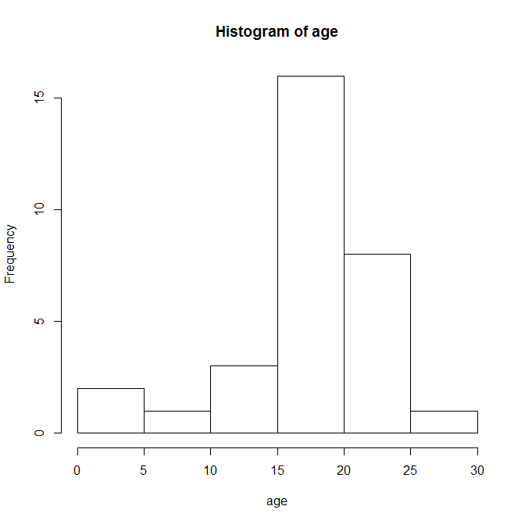
  - Age groups: 1-10, 11-20, 21-30?
The following graphs show potential sites from each age group (3 groups in total). The age of stand are marked. Blue line indicates the border between piedmont and coastal plain. For each age group, I try to pick up two sites at each physiographical region with similar age and latitude.
  - Young stand (4 sites in total: 3 sites from Andy’s selection, 1 sites from culled sites, 3-7 years old)
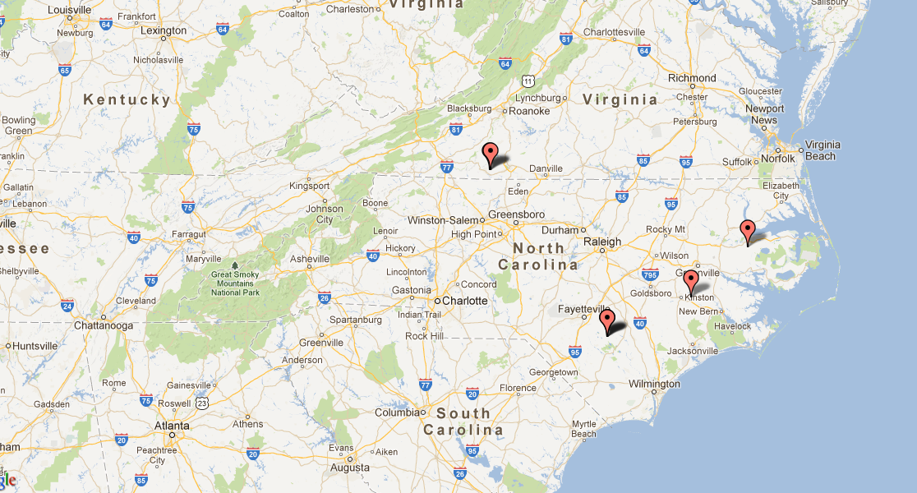
3
3
3
7

  - Medium stand (19 sites, 13-20 years old)
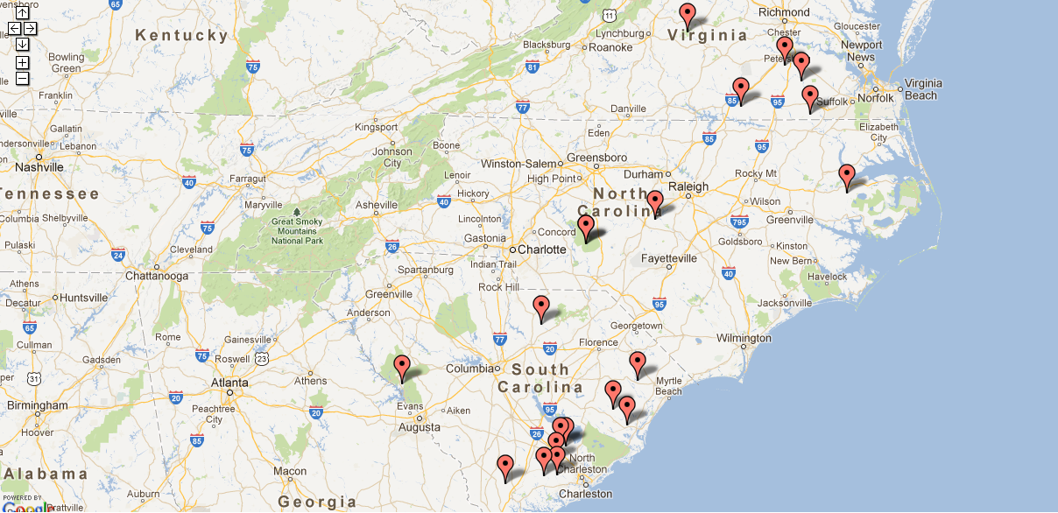
16
18,18
16
18,19
18
15
17
16
13
14
18
19
17
16
18
20
20

  - Old stand (9 sites, 21-28 years old)
    - Because the age of stands from medium age group is around 18, I hope to pick up stands no younger than 23 years old. But it is hard to find out such a pair at similar latitude, though culled sites are considered (the next graph).
28
22
21
23
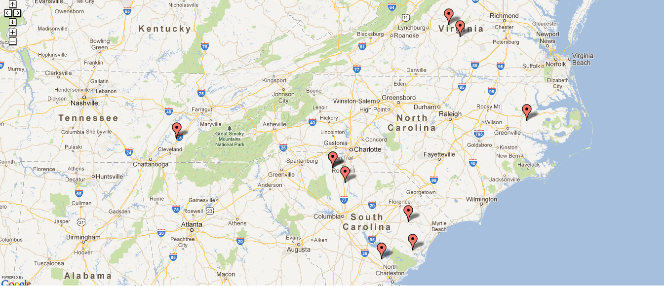
21
21
21
23
22

Culled old sites (7 sites, age 21 to 23)
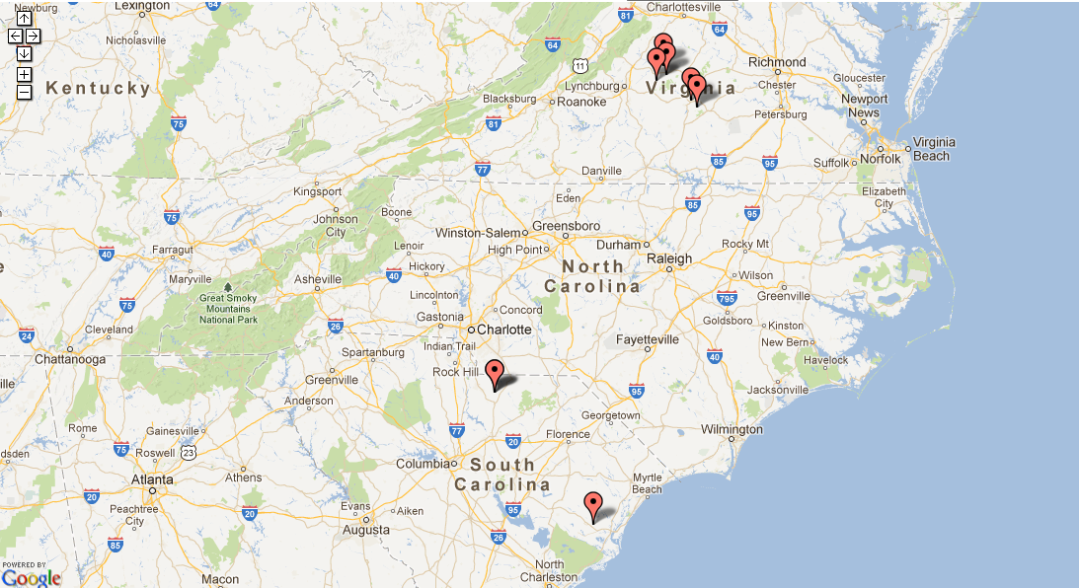
2121
23
23
21
23
22

