SAPFLOW WORKSHOP
November 11, 2011
North Carolina State University

Granier-style Thermal Dissipation Probes Assembly Protocol
9/15/2009 CM
Revised 5/12/2011

Note: An assembly-line method works best when making these probes. Repeat each step so that several pieces are prepared for the following step.

Needle preparation:

Material
- 19G 1.5 stainless steel hypodermic needles
- Dremel tool with cutting disc
- Safety glasses

Cut needles using a Dremel tool to 20 mm in length from the base of the metal needle. Once cut, bevel the tip to an angle a little greater than 45 degrees (Fig 1). Use the Dremel to lightly sand the edges of the beveled tip so that they are smooth. When wrapping the heater wire around the needle, the beveled tip provides a gripping point.

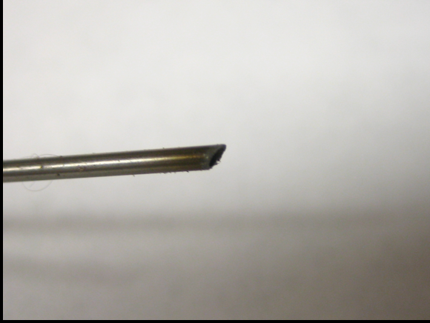Fig 1

Using another uncut needle, puncture the hub just past the ridges moving toward the base of the hub of each needle (Fig 2). This hole allows air to escape when filling the hub with epoxy and will be used to feed one end of the heater wire back through the probe.

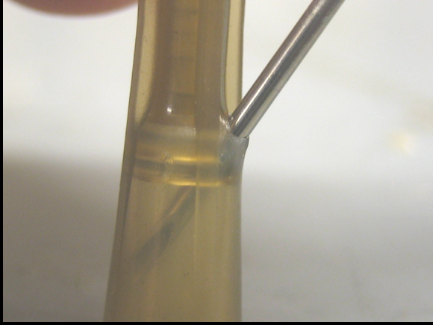Fig 2

Note: Sometimes after cutting the tips of the needle, there will be pieces of metal in the interior of the needle. Use an uncut needle or the wire end of a resistor to clean out the edge of the interior. If metal pieces are left in the interior of the needle, they may damage or block the heater wire.

Aluminum sheath preparation:

Materials
- Aluminum tube, round 3/32” OD, 0.014 nominal wall
- Dremel tool with cutting disc or razor blade and file
- 1/16” drill bit or small diagonal cutting pliers

Cut 20 mm lengths of aluminum sheathing, either with the Dremel or with a razor. To cut with a razor, score around the circumference of the tube by rolling it along a flat surface with the razor. After the tube has been scored, it can be cleanly snapped-off with a quick bend along a sharp table edge. Once cut, smooth each end with the flat side of the cutting wheel or a file. Using a needle, clean out any residual metal from the inside of the tube. Sand or file down the outer edges of the cut ends so they are slightly angled. The angle helps the probe slide into the tree when installing.

Once all the sheaths are prepared, use a 1/16” drill bit to slightly sand out the interior of the sheath or use the tips of diagonal cutting pliers to slightly flare out the edges of the sheathing. This step may be helpful for sliding the sheaths over the heater probes without damaging the delicate heater wire.

Wire preparation:

Materials:
- Copper-constantan thermocouple wire, 0.019x0.030” (0.48x0.76 mm)
- Constantan heating wire 0.005” (0.12 mm) diameter
- Diagonal cutting pliers
- Razor blade
- Solder
- Soldering flux
- Super glue
- Multimeter

Thermocouple
For each thermocouple, cut one piece of the paired copper-constantan wire to 16 cm. Strip one end of each wire gently with sharp diagonal cutting pliers (make sure not to create an indentation in the wires; this will reduce the integrity of the wire and they will break).

Once the wires are stripped, twist them together tightly so that they are closely coupled all the way to the shielding (Fig 3). Dip the twisted wires in soldering flux and solder the twisted thermocouple. You only need a small amount of flux and a small amount of solder. It is often easiest to form a small bead of solder on the soldering iron tip and brush the thermocouple junction through the bead. Clip off the extra length of twisted thermocouple so that the exposed metal is as short as possible. Dip the exposed metal in super glue so that the metal is coated with a thin film. Make sure that the connection is smooth, not rough, so that it will be easy to insert into the needle shaft.

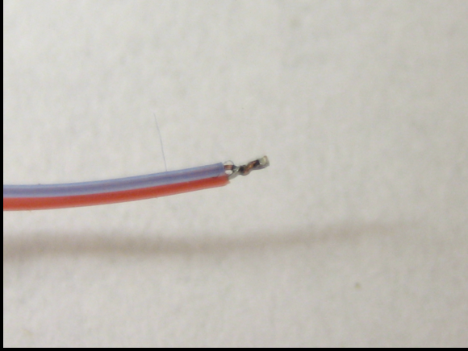Fig 3

Using a sharp razor blade, lay the thermocouple wire flat on a level surface and carefully cut the clear plastic casing lengthwise between the red and blue wires. This only requires a small amount of pressure and you must be very careful not to nick the red or blue coating of the wires. Remove the rest of the clear plastic coating so the red and blue coated wires are exposed. Next, with a razor blade or fingernails, strip 1-2 cm of the red and blue coating off the tail end of each of the wires, exposing the copper and constantan metals. Using a multi-meter, verify that there a circuit is completed between the copper and constant end (through the soldered junction).

The thermocouple junction must be in the middle of the length of the needle shaft (1 cm from the tip of the needle and 1 cm from the hub). For correct placement of the thermocouple, the wire will need to be inserted 1.75 cm through the hub plus 1 cm through the needle shaft. Use a ruler and put a kink in the thermocouple at this length. Now, when you insert the thermocouple, you will know that the thermocouple junction is correctly aligned when the kink lines up with the base of the needle hub (Fig 4).

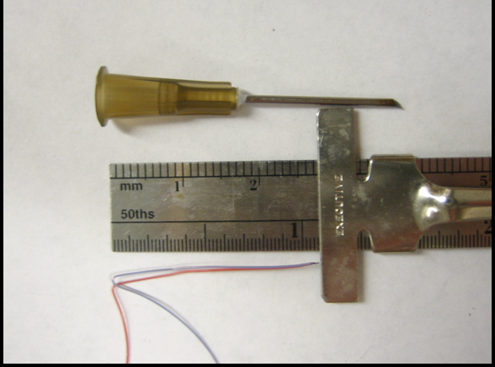Fig 4

Heater wire
Cut a piece of single-stranded constantan wire, 40 cm in length. Be careful not to kink or nick the wire.

Probe Assembly

Materials
- Prepared thermocouple wires (see above)
- Prepared heater wire (see above)
- Prepared needles (see above)
- Prepared aluminum sheaths (see above)
- Super glue
- Epoxy
- 3 mL syringe
- Thermal conductivity paste
- Multi-meter

Reference Probe, wire insertion
Take one of the prepared thermocouples and insert it into the hub end. Insert until the kink in the wires is flush with the base of the hub (Figs 5 & 6). Using the multi-meter verify that you still have a complete circuit between the copper and constantan tails. Also, verify that you do not have a complete circuit between either of the tails and the metal needle. This connection between the metal of the thermocouple junction and the metal needle can compromise measurements. If you do have a connection, add another coating of super glue to the thermocouple junction. Once the thermocouple is in place, slowly add several drops of super glue into the head of the needle. Capillary action will wick the glue through the needle and help to hold the thermocouple in place. Allow the super glue to dry for several hours or overnight.

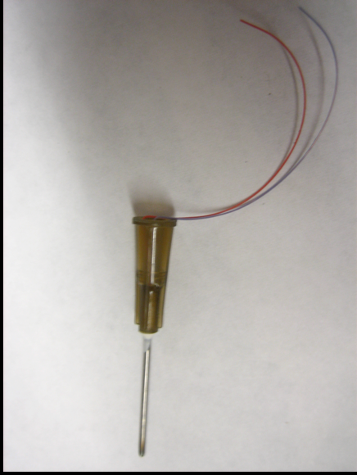Fig 5 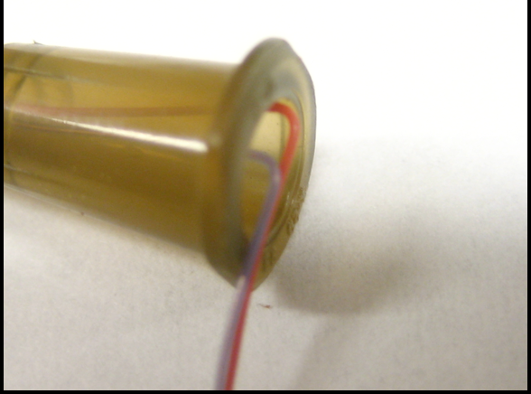 Fig 6

Heater Probe, wire insertion
First, insert the prepared heater wire from the hub end into the shaft of the needle and push through until the wire comes through the tip, once about 2 cm of the heater wire has exited through the tip of the needle, insert a prepared thermocouple into the hub end of the needle. If the thermocouple will not easily slide into the shaft, pull the heater wire while pushing the thermocouple into the needle (being careful not to scrape off the heater wire coating on the tip of the needle). Also, if the thermocouple will still not slide into the needle shaft, remove the heater and thermocouple wires and use the tip of an uncut needle to bore out the hole in the hub that leads to the needle shaft. This should widen the opening and allow for easy insertion of the heater and thermocouple wires.

Pull the heater wire through the shaft until there is only 3 cm of wire extended past the base of the hub (roughly even with the thermocouple tails). As with the reference probe, check to make sure that there is a circuit connection between the two thermocouple tails, but not the thermocouple tails and the needle shaft. (Fig 7).

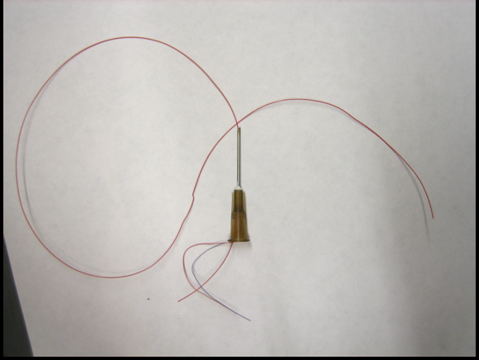Fig 7

Both probes, epoxy step
Fill the hub end of the reference and heater probes with epoxy. Mix the epoxy on a sheet of paper and funnel the epoxy into the 3 mL syringe. This allows you to fill the hub easily. Do not fill either of these probes above the additional hole that you’ve bored out of the side of the hub (you’ll still need to feed one end of the thermocouple wire through here). Position the probes vertically with the hubs at the top and allow the epoxy to dry overnight.

Heater probe, wire wrapping
Take the long end of the constantan heating wire extending from the tip of the heating probe and gently but firmly wrap the wire around the needle shaft. (Fig 8)

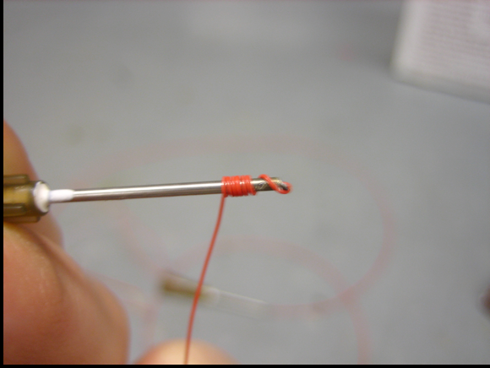Fig 8

Be careful when starting the wrapping not to nick the wire on the needle edge. Make sure there are no spaces between each wrap and that no wrap is overlapping another. Wrap the wire down the length of the 2 cm needle, then once at the base of the needle (top of the hub), insert the end of the wire into the prepared hole in the side of the hub. Cover the needle with thermal conductivity paste and carefully slide the sheath over the wrapped needle. Add a drop of epoxy or crazy glue to the base of the needle to secure the heater wire tail.

Fig. 9. Schematic of heat dissipation sap flow probe pair

